2025

CCBF
Annual Expenditure Reporting

Instructions

Table of Contents

Table of Contents 1
What’s new for 2025 2
How Do I Access PIMS? 4
How Do I Find My Annual Expenditure Report? 5
Contact Details 6
What Must Be Completed? 7
Completing the Project Reporting Tab 8
Creating a New Project 12
Adding New Project Information 13
Making a Prior Year Adjustment 17
Completing the Program Reporting Tab 19
Completing the Financial Officer Certification Form 21
Submitting the Annual Expenditure Report 22
Appendix 1 – Housing Infrastructure Definitions 23
Appendix 2 – Project Report Example 24

What’s new for 2025
The April 30, 2026 – June 1, 2026 reporting cycle collects information covering the 2025 calendar year and represents the second full year of reporting of the Renewed CCBF Agreement. All CWF recipients are required to information related to progress in the area of project related housing infrastructure.
As part of the new reporting requirements for the 2024-2034 CCBF Administrative Agreement, this year’s reporting cycle will collect the following information:
- Outputs and outcomes reporting for new and existing projects including:
  - Housing units and affordable housing units enabled, supported, or preserved (Definitions found on page 23)
  - Qualitative response for the project’s impact on housing
  - Number of communications/signs

- A CWF Project reporting template is available to help local government staff share and collect project data / information before reporting the project in PIMS
- To support compliance and track progress, UBCM staff may contact local governments with significant unspent Community Works Fund balances to request additional information on how funds will be utilized within the established timelines.

- The following Ultimate Recipients will be required to complete an additional housing survey that will be provided at a later date by UBCM Staff:
  - Abbotsford
  - Campbell River
  - Chilliwack
  - Kamloops
  - Kelowna
  - Langford
  - Mission
  - Nanaimo
  - North Cowichan
  - Penticton
  - Prince George
  - Saanich
  - Vernon
  - Victoria
  - West Kelowna
CWF Project Reporting
- All complete CWF projects must be reported
- All CWF projects with spending in 2025 must be reported
- Complete and on-going projects must report on outcomes and outputs

How Do I Access PIMS?
- PIMS is an online database where local government staff can find all information related to the Canada Community-Building Fund.
- Users will access PIMS through their internet browser by navigating to https://pims.ubcm.ca
- If you are new to PIMS or can’t remember your email or password, email CCBF staff at pims@ubcm.ca for assistance.

How Do I Find My Annual Expenditure Report?
Once you are logged into PIMS, click ‘Annual Expenditure Reports on the left side of the page.
You should see the top panel “Draft Submission in Progress”. Click on 2025 under “Reporting Year” and click on the four-digit AER ID to access your AER.
Prior year AER’s are located below the 2025 Draft Submission

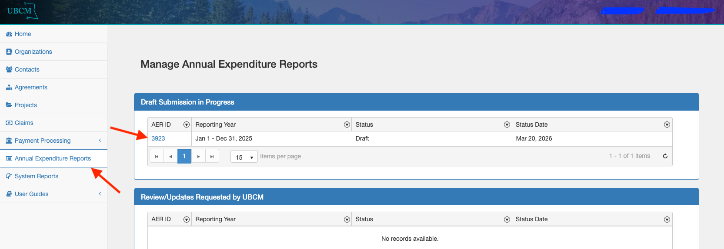

Contact Details
Once in your 2025 AER, you are required to provide the following contact information:
- Contact Name: Full name of the person CCBF staff can contact for any questions about your AER.
- Phone Number: The best phone number to reach the contact for any questions about your AER.
- Email Address: The best e-mail address to reach the contact for any questions about your AER.
Once complete, scroll to the bottom of the page where you will find four tabs required for completing the AER: Project Reporting, Program Reporting, Related Forms, Attachments.
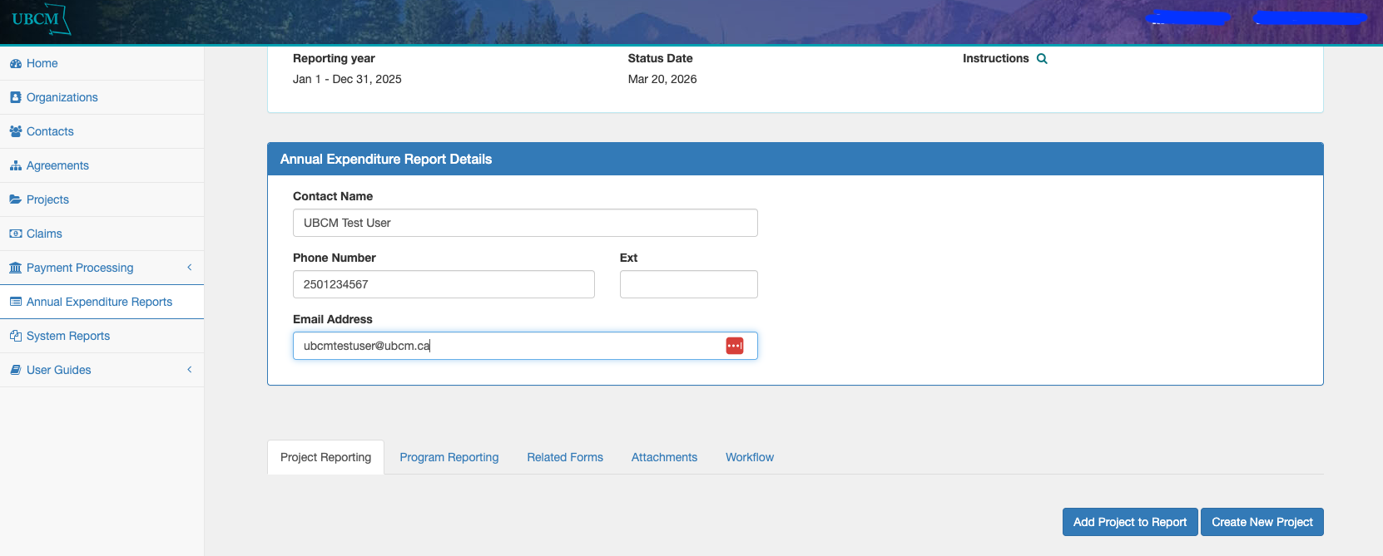

What Must Be Completed?
You will find four tabs at the bottom of your AER:
- Project Reporting Tab: This is where you will add project- specific expenditure information.
- Program Reporting Tab: This is where you will find a summary of what you’ve entered in Project Reporting tab and answer questions on interest earned.
- Related Forms Tab: There are no related forms for the 2025 AER Reporting Cycle.
- Attachments Tab: This is where you will attach your mandatory completed Financial Officer Certification form and attach a completed CWF Allocation Template if required.

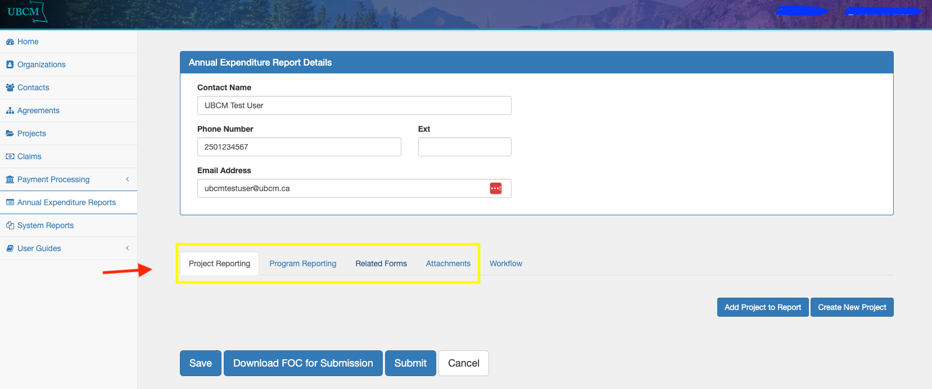

Completing the Project Reporting Tab
Adding Existing Projects
- Click on the Project Reporting tab and click the ‘Add Project to Report’ button
- The ‘Add Project(s) to Annual Expenditure Report’ table will appear. Using the first column with check boxes, select which project(s) you would like to appear in your 2025 AER.
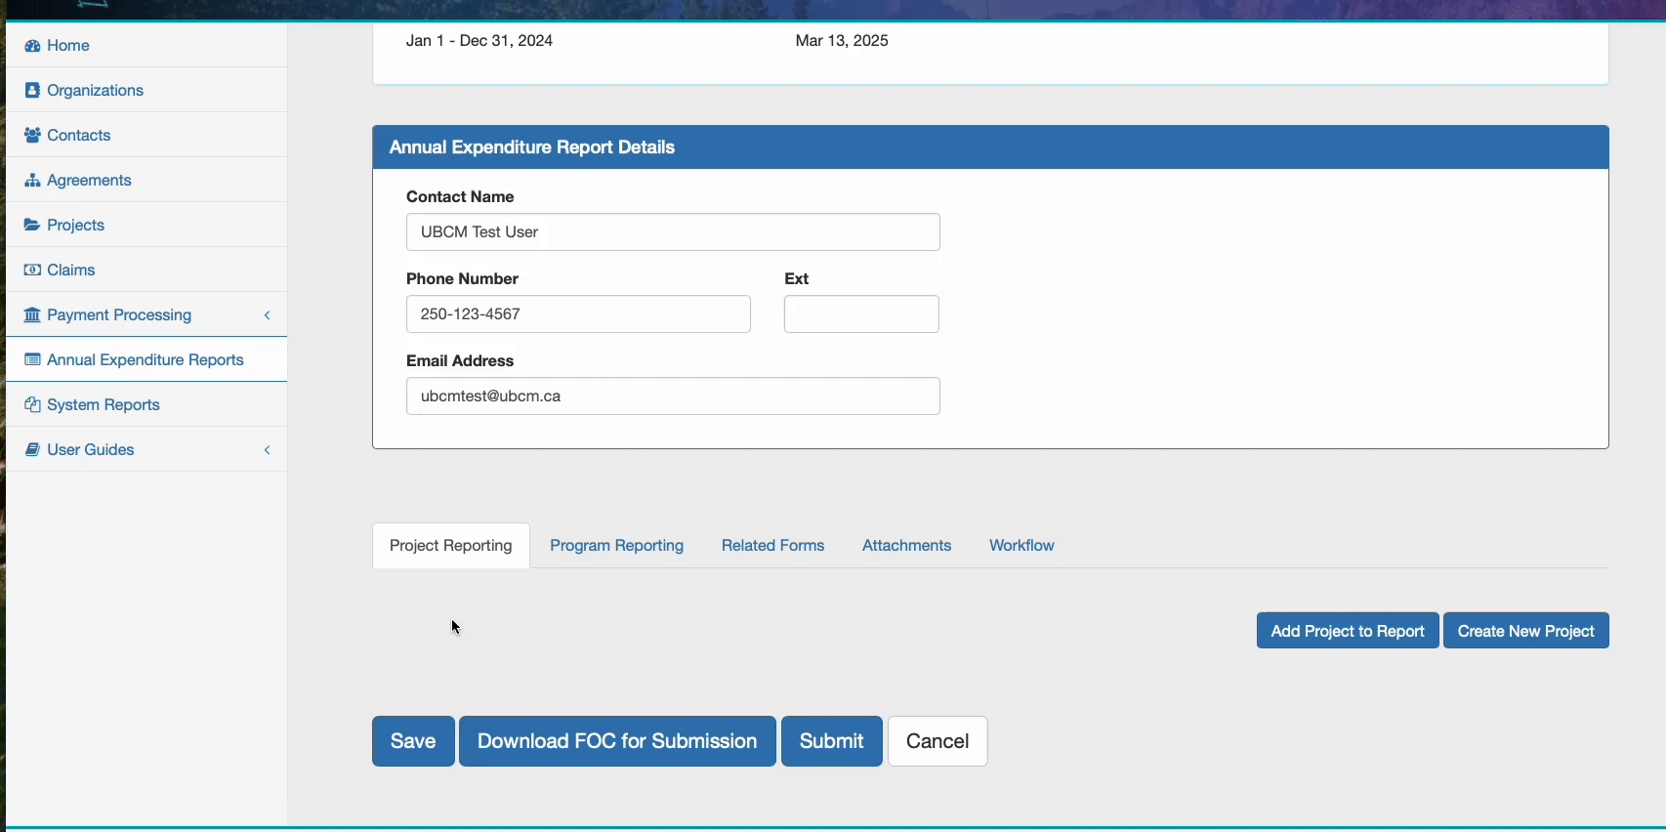

Adding Existing Projects (continued)
- Once the project(s) has been added, you are required to complete all information, as of December 31, 2025. The following fields are mandatory:
- Percentage of Project Complete
- Project start date
- Project Completion Date
- Total CWF spent in Reporting Year
- Upon completion of Step #3, navigate to the project page to complete required updates. **All pre-existing projects in PIMS will need to be updated to include outputs data and, if complete, outcomes/housing data. Complete details on this process can be found on pages 12-15 of this reporting guide.

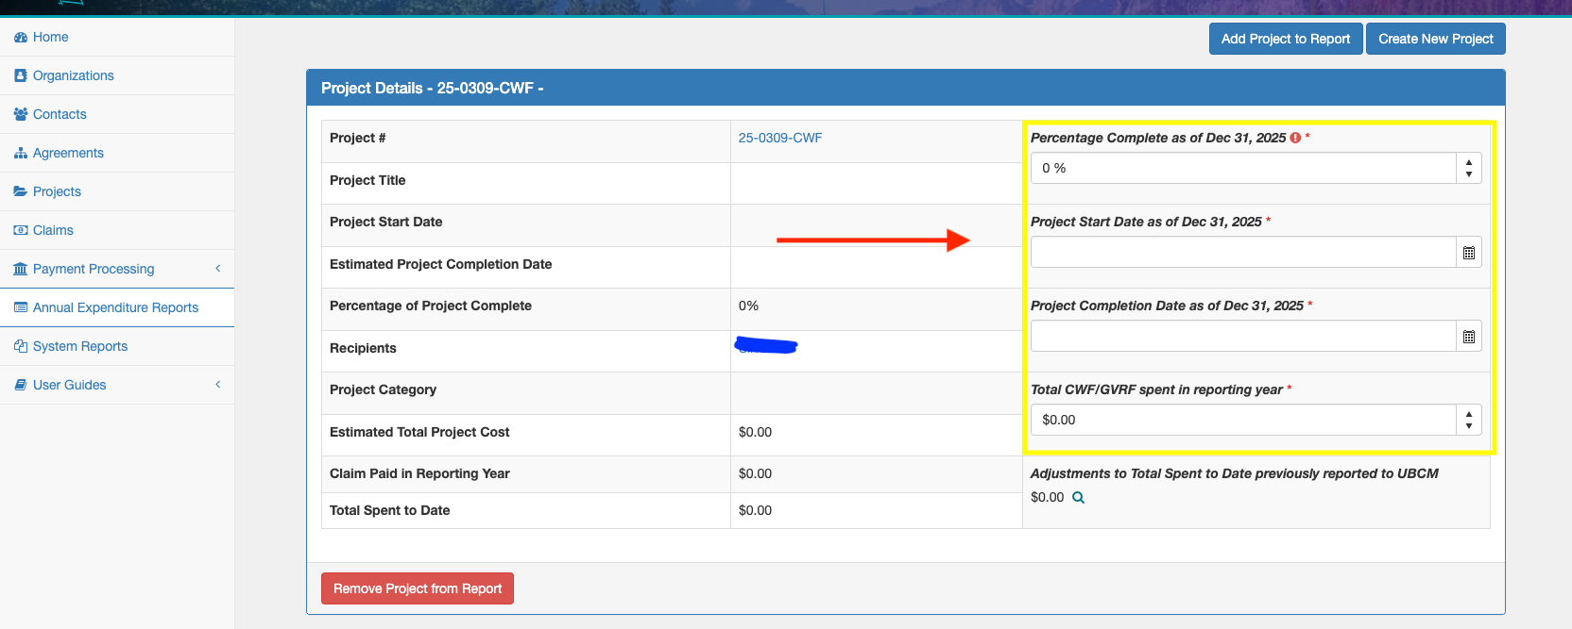
Editing Existing Projects
- To navigate to the project page and complete the required updates, in the ‘Project Details’ table, click the blue hyperlinked project number to go to the project page. Scroll to the bottom of the page and click edit.
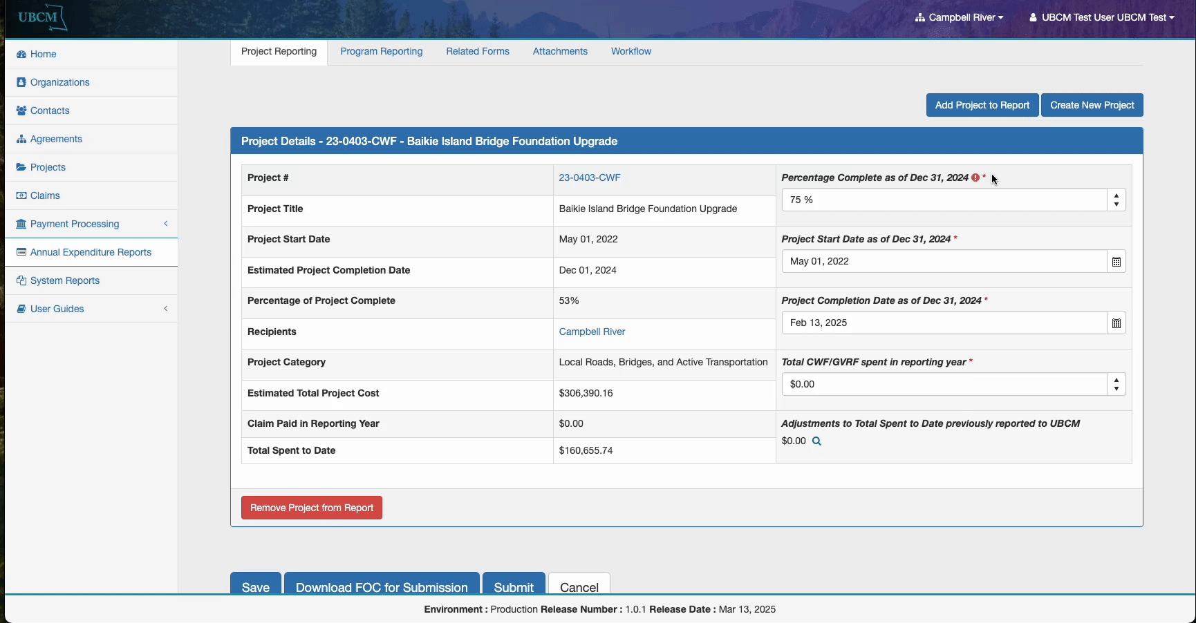
- Make the necessary updates to your CWF or MVRF project including
  - Project Output Metrics
  - Geolocation (instructions on page 13)
  - Population Served
  - Project Outcome Metrics (if project is complete)
  - Housing Related Infrastructure Outcome Metrics and related narrative
  - Communication/Signage Activity
- Scroll to the bottom and ensure you click Save and update the status of your project.
- To navigate back to your AER, click on the ‘Annual Expenditure Report’ breadcrumb at the top of the page.

- Note that SPF projects with claims in the 2025 calendar year have been added to your AER for ease of reporting. Please contact UBCM staff if you are going to remove the SPF project. (Double click to play gif below).
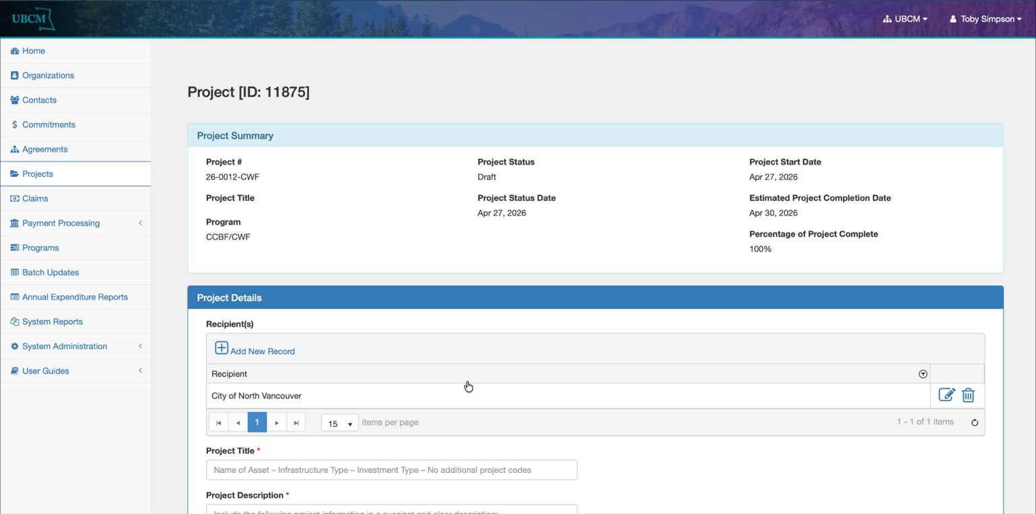

Creating a New Project
Adding New Projects
- Click the ‘Create New Project’ button. This will take you to the CWF create a project screen where you will enter the below under the ‘Project Details’ heading:
- Project Title  - Project Description  - Project Category  - Project Start Date  - Estimated Project Completion Date  - Percentage of Project Complete  - Actual Project Completion Date  - Total CWF Funding Allocated  - Total Project Cost | - Type of Investment*  - Output Indicator, Value and Metric*  - Outcome Indicator, Value and Metric*  - Geolocation of Project*  - Population Served by Project*  - Housing Units Enabled, Supported, or Preserved*  - Affordable Housing Units Enabled, Supported, or Preserved*  - Qualitative Housing Response*  - Number of Communications/Signs*  - KML files (if available)*
*Further guidelines for new reporting requirements are found on the following pages.
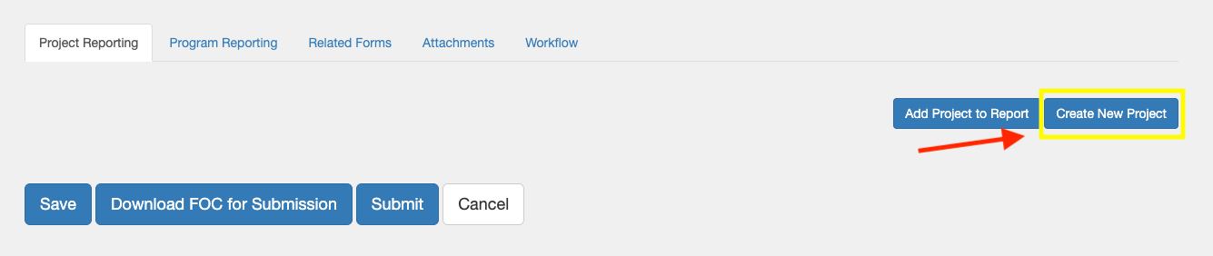

Adding New Project Information
- The following information is required to be entered into PIMS in order to create a project. Once the project is created, it must be added to the Annual Expenditure Report following the instructions on the previous pages.
  - Project Title: Provide a meaningful and descriptive project title that include the name of asset and/ or project location. Do not use abbreviations.
  - Project Description: Provide a meaningful project description which includes the name of the asset, project location, infrastructure type, investment type, all project output and project outcome metrics. Identify if the project invests in a non-local government owned asset (3rd party project).
  - Project Category: Select the project category that best aligns with your project. For projects with more than one investment category (ex., road and sewer), select the category with the highest investment of CWF funding.
  - Project Start Date
  - Estimated Completion Date
  - Percentage of Project Complete at time of reporting. Note that this amount needs to be updated during the life of the project.
  - Type of Investment: Select primary type of investment that best aligns with your project. For projects with more than one investment type, select the one with the highest investment of CWF funding.
  - Output Indicators: Select from one of two output indicators best associated with your project category. You must select the output indicator directly associated with your project.
  - Numeric output indicator value. Select the appropriate output indicator metric for your project category.
  - If your project is complete (reported at 100%), you will be required to complete the Outcome Indicator and Metric reporting. Outcome Indicator reporting functions the same as Output Indicator reporting (see ‘h’ and ‘i’ above), but with different Indicators and Metrics to choose from. You must select the outcome indicator directly associated with your project.
  - Provide the geolocation for your project by:
    - Clicking on the hyperlink that says Click Here for Google Maps.
    - Once in Google Maps, right click on the project location, then left click the geolocation to copy the location to your clipboard.
    - Navigate back to PIMS and paste the geolocation in the appropriate cell.
  - Provide Population Served directly by the project
  - If your project is complete (reported at 100%), indicate if your project Enabled*, Supported* or Preserved* Housing Supply in your community (or select Not Applicable). Provide the total Number of Housing Units enabled, supported or preserved by the project and (from the total housing units) the Number of Affordable* Housing Units enabled, supported or preserved by the project. (*Definitions to follow)
“Affordable Housing” is defined as a dwelling unit where the cost of shelter, including rent and utilities, is a maximum of 30% of before-tax household income. The household income is defined as 80% or less of the Area Median Household Income (AMHI) for the metropolitan area or rural region of the Ultimate Recipient.
“Enable housing supply” is defined as a project creating the conditions needed for new housing to be built. Generally connected with the ‘New Construction’ and ‘Expansion’ types of investment.
“Support housing supply” is defined as a project helping existing or planned housing by improving quality of life, access, or affordability. Generally connected with the ‘Enhancement or Rehabilitation’ type of investment.
“Preserve housing supply” is defined as a project protecting or maintaining existing housing from being lost, damaged, or made uninhabitable. Generally connected with the ‘Replacement’ type of investment.
  - Provide the Number of Communications/Signs that were done for the project. Attach any available photos in the Attachments tab on the Project page.
  - Provide the Total CWF / MVRF funding allocated to your project for the entire life of the project. This number must be adjusted if it increases or decreases in following years.
  - Provide the total project cost of the project.
Note: See ‘Appendix 2 for example responses to the project fields listed above.
- Click Save at the bottom of the screen to save any on-going progress. (The .gif below covers points #1 & #2)
- Navigate to the ‘Status Change’ button at the bottom of the screen. The ‘Status Update’ table will appear. Change the project status from ‘Draft’ to ‘In Progress’ and then click the ‘Update’ button.
- To navigate back to your AER, click on the ‘Annual Expenditure Report’ breadcrumb at the top of the page or the side bar.
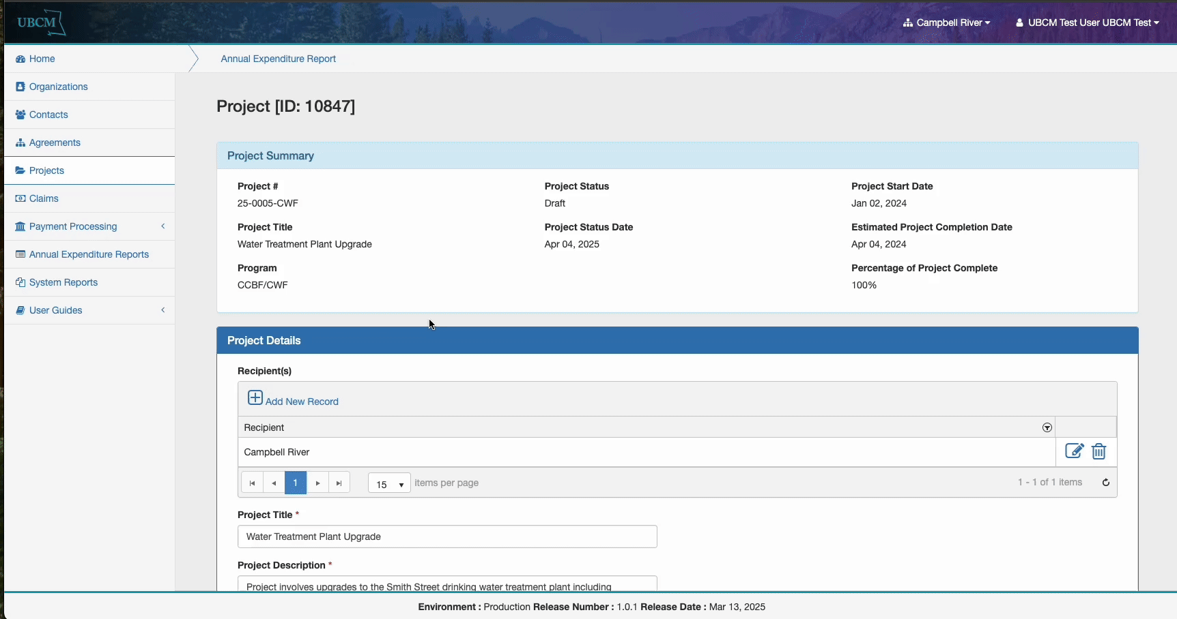
- Add the project to your 2025 AER following the instructions on page 7 of this guide.
- Once the project(s) has been added, you are required to complete all information as of December 31, 2025.The following fields are mandatory:
- Percentage Complete as of Dec 31, 2025
- Project Start Date as of Dec 31, 2025
- Project Completion Date as of Dec 31, 2025
- Total CWF or GVRF spent in reporting year
- Once complete, scroll to the bottom of the report and click the ‘Save’ button. A message will appear advising you have saved your progress.

Making a Prior Year Adjustment
- Click the magnifying glass next to ‘Adjustments to Total Spent to Date Previously Reported to UBCM’
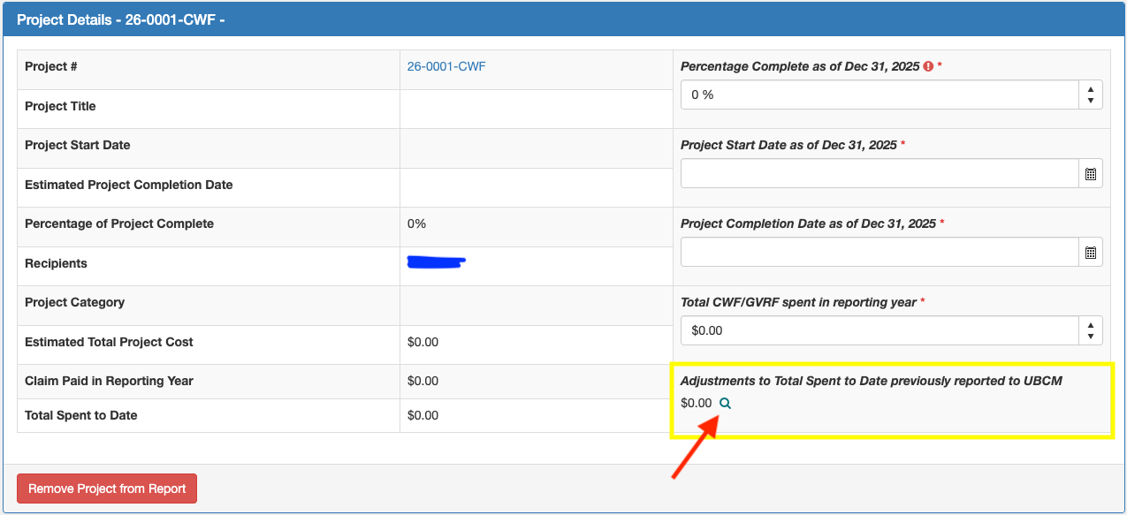
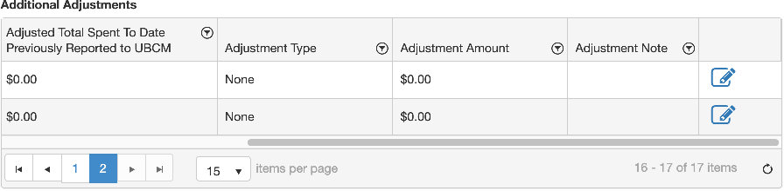

- Locate the ‘Reporting Year’ row that you would like to adjust. Using the bottom scroll bar, move to the right of the table and click the ‘Edit’ button (pencil icon).
- In the ‘Adjusted Total Spent to Date Previously Reported to UBCM’ column, enter the correct value.
- Please enter rationale for the adjustment in the ‘Adjustment Note’ column.
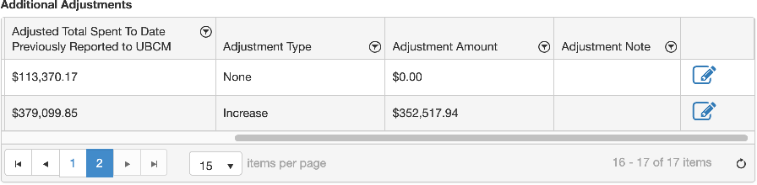

- Once complete, click the ‘Save’ button at the end of the row and ensure that the ‘Adjustment Type’ column reads properly as ‘Decrease’ or ‘Increase’ and that the ‘Adjustment Amount’ is correct.
* When making any adjustments to prior year spending, we recommend connecting with CCBF staff to discuss the changes.

Completing the Program Reporting Tab
- Once all projects have been entered in the ‘Project Reporting’ tab, navigate to the ‘Program Reporting’ tab. Most of the fields are populated, but you must report any interest earned in 2025.
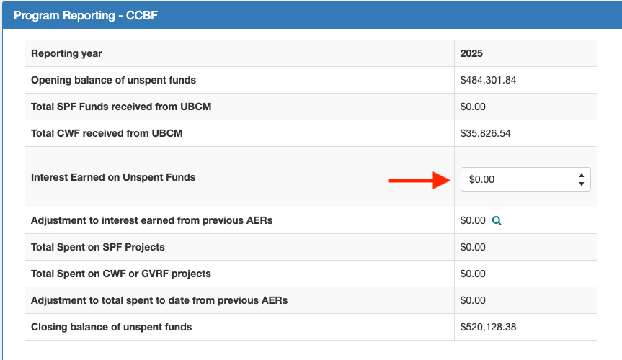
- Once complete, scroll to the bottom of the page and click ‘Save’ to ensure you do not lose your work.
- If you need to make any adjustments to interest earned in prior years, you can do so by clicking on the magnifying glass in the ‘Adjustment to interest earned from previous AERs line’
- In the ‘Adjustment to Interest Earned from previous AERs’ table, locate the year you would like to adjust and scroll to the right and click the edit button.
- In the ‘Adjusted Total Spent to Date Previously Reported to UBCM’ column, enter the ‘Adjusted Interest Earned’ as the correct amount of interest and click save.
- Verify that the ‘Adjustment Type’ reads correctly as ‘Decrease’ or ‘Increase’.
- Once verified and saved, click ‘Close’ to navigate back to your Annual Expenditure Report.

Completing the Financial Officer Certification Form
- Scroll to the bottom of any tab of the Annual Expenditure Report and click the ‘Download FOC for Submission’ button.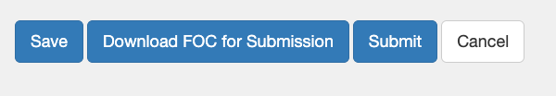
- A PDF document will be saved to your computer’s downloads folder. Open the PDF and have your Acting/Active Financial Officer with Financial Signing Authority complete and sign the form.
- Once complete, navigate to the Attachments tab and upload the form using the instructions below. Be sure to select your file, then add your file and save your AER.
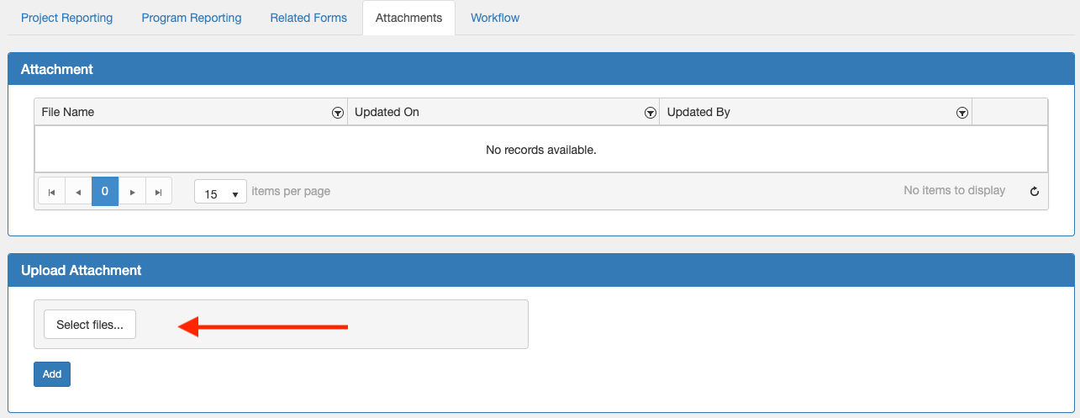

Submitting the Annual Expenditure Report
- Once you have completed everything and are ready to submit, scroll to the bottom of your report, and click the ‘Submit’ button.
- A pop-up window will appear. Click on the dropdown menu ‘Status Name’, select ‘Submitted’ and click the “Update” button.
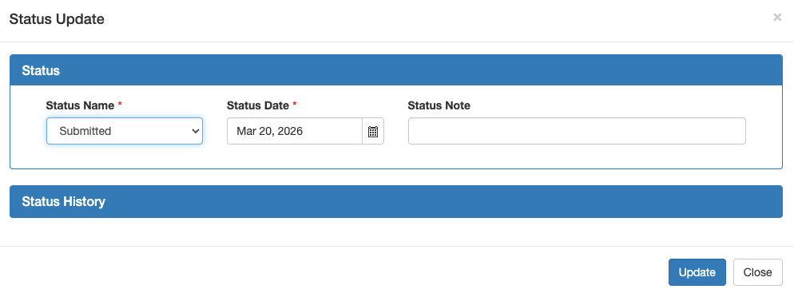
- Once submitted, UBCM staff will review your Annual Expenditure Report. Should we have any further questions we will follow up via e-mail.
Note: Once submitted and under review by UBCM Staff, your Annual Expenditure Report (AER) will no longer be accessible to you in PIMS. You will be able to access your AER upon approval or if changes are requested by UBCM Staff.

* If you have any difficulties completing you Annual Expenditure Report, please email CCBF@ubcm.ca or call 250-356-5134 for assistance.

Appendix 1 – Housing Infrastructure Definitions
“Affordable Housing” is defined as a dwelling unit where the cost of shelter, including rent and utilities, is a maximum of 30% of before-tax household income. The household income is defined as 80% or less of the Area Median Household Income (AMHI) for the metropolitan area or rural region of the Ultimate Recipient.

“Enable housing supply” is defined as a project creating the conditions needed for new housing to be built. Generally connected with the ‘New Construction’ and ‘Expansion’ types of investment.
“Support housing supply” is defined as a project helping existing or planned housing by improving quality of life, access, or affordability. Generally connected with the ‘Enhancement or Rehabilitation’ type of investment.
“Preserve housing supply” is defined as a project protecting or maintaining existing housing from being lost, damaged, or made uninhabitable. Generally connected with the ‘Replacement’ type of investment.

Appendix 2 – Project Report Example
The following is an example response for each section of the Project Record. This appendix is meant for illustrative purposes. If you have any questions, please reach out to CCBF Staff at CCBF@ubcm.ca or 250-356-5134.

Project Title: UBCMVille 2nd Street Water Main Pipe Replacement
Project Description: Project involves replacing 1 kilometer of deteriorating water main piping at the end of service life on 2nd street between City street and Town road. The current 5-millimeter pipe will be replaced by reinforced 7-millimeter pipe for improved water service to the downtown area, preserving housing and enabling growth in the surrounding area.
Project Category: Drinking Water
Project Start Date: Dec 15, 2021
Estimated Project Completion Date: Nov 11, 2025
Percentage of Project Complete: 100%
Actual Project Completion Date: August 27, 2025
Type of Investment: Replacement
Output Indicator: Drinking water – Length (m) of increased or improved pipe
Output Indicator Numeric Value: 1000
Output Indicator Metric: m
Outcome Indicator: Drinking water – Volume (m^3) in total daily treated daily
Outcome Indicator Numeric Value: 100
Outcome Indicator Metric: m^3
Geolocation: 48.417868764260305, -123.3685870954128
Population Served Indicator Value: 1500
Does this project enable, support or preserve housing supply in your community?: Preserve
Number of Housing Units enabled, supported, or preserved: 750
Number of Affordable Housing Units enabled, supported, or preserved: 50
Qualitative Housing Response (Housing Co-Benefits): In addition to preserving essential water service to the total 750 housing units (50 of which are considered affordable) in the downtown area, this project improved the capacity of the 2nd street water main to enable planned housing supply growth in the area. It is estimated that the increased capacity will enable service to an additional 100 housing units (of these, 5 will be affordable housing units).
The Affordable Housing Units were determined in alignment with the definition provided on the 2024-2034 CCBF Administrative Agreement (a unit where costs are a maximum of 30% of before-tax household income. The household income is defined as 80% or less of the Area Median Household Income*). UBCMVille’s Affordable Housing Threshold is $1,440 per month (Area Median Household Income = $6,000/month or $72,000/year before tax, Household Income = $72,000*0.8 = $57,600/year, Affordable Housing = $57,600*0.3 = $17,280/year or $1,440/month).
*To find your Area Median Household Income, please consult your OCP, HNR, or StatsCan demographic data for your Metropolitan Area or rural region. Otherwise put your best estimate for median household income.

Number of Communications/Signs: 1

*A photo of the sign will be attached in the attachments tab on the project record.

