COMMUNITY WILDFIRE
RESILIENCY PLAN
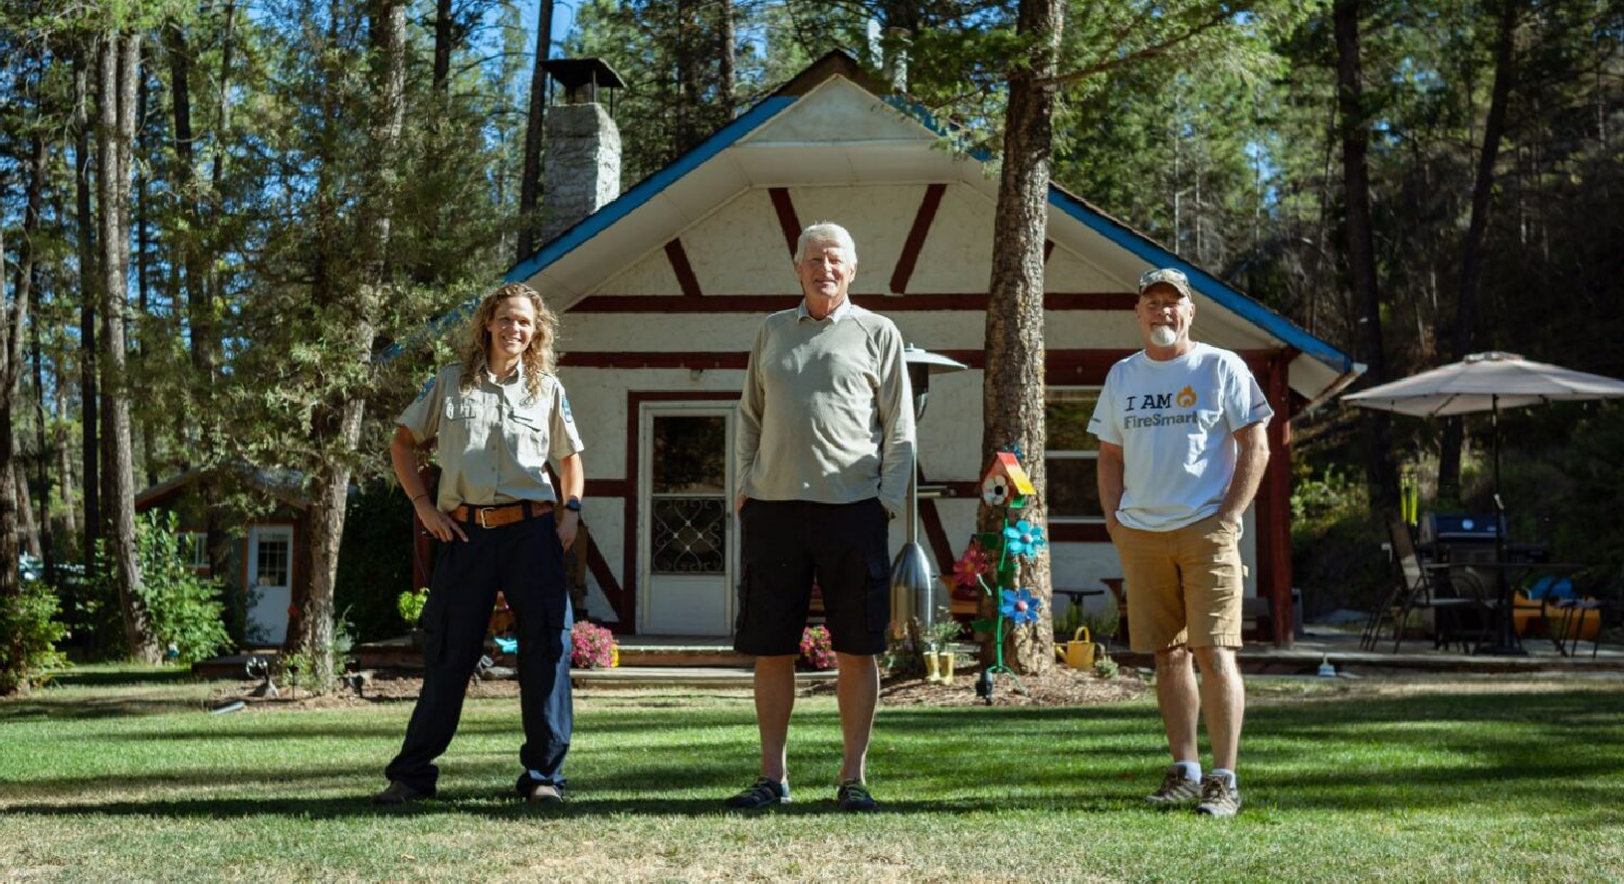

[Community Name]
[Date]

[Community logo]
[Partner logo]
[Partner logo]
[Partner logo]

[Name]  [Title]  [Organisation] |  | [Date]
[Name]  [Title]  [Organisation] |  | [Date]
[Name]  [Title]  [Organisation] |  | [Date]
[Name]  [Title]  [Organisation] |  | [Date]

Table of Contents

1. Tables and Figures 2
2. Acknowledgments 3
3. Frequently Used Acronyms 1
4. Executive Summary 2
5. Introduction 3
5.1 Overview 3
5.2 Plan Goals 3
5.3 Plan Development Summary 3
6. Relationship to Other Plans 4
7. Community Description 6
7.1 Area of Interest 6
7.2 Wildland-Urban Interface 6
7.3 Community Information 6
8. Wildfire Risk Assessment 7
9. Education 8
10. Legislation and Planning 9
11. Development Considerations 10
12. Interagency Cooperation 11
13. Cross-Training 12
14. Emergency Planning 13
15. Vegetation Management 15
16. Action Plan & Implementation 16
17. Appendices 19
17.1 Appendix A: Glossary of Terms 19
17.2 Appendix B: Public Engagement 19
17.3 Appendix C: Home Ignition Zone 19

1. Tables and Figures

2. Acknowledgments
For guidance on this section, see the Community Wildfire Resiliency Plan Instruction Guide Part 2: CWRP Template (Front Matter).

3. Frequently Used Acronyms
AOI Area of Interest
BC British Columbia
BCWS British Columbia Wildfire Service
BEC Biogeoclimatic Ecosystem Classification
CFFDRS Canadian Forest Fire Danger Rating System
CFS Community Funding and Support
CI Critical infrastructure
CIFFC Canadian Interagency Forest Fire Centre
CRI Community Resiliency Investment
CWRP Community Wildfire Resiliency Planning
DP Development Permit
DPA Development Permit Area
EMBC Emergency Management British Columbia
EPA Emergency Program Act
FBP Fire Behaviour Prediction System
FESBC Forest Enhancement Society of British Columbia
FESIMS Forest Enhancement Society Information Management System
FMP Fire Management Plan
FSCCRP FireSmart Canada Community Recognition Program
FNESS First Nations Emergency Services Society
HIZ Home Ignition Zone (also see Structure Ignition Zone)
HRVA Hazard Risk and Vulnerability Analysis
HVRA High Value Resources and Assets
LRMP Land and Resource Management Plan
MFLNRORD Ministry of Forests, Lands, Natural Resource Operations and Rural Development
MOTI Ministry of Transportation and Infrastructure
PSOE Provincial State of Emergency
PSTA Provincial Strategic Threat Assessment
OCP Official Community Plan
OFC Office of the Fire Commissioner
RSWAP Resource Sharing Wildfire Allocation Protocol
SOLE State of Local Emergency
SWPI Strategic Wildfire Prevention Initiative
UBCM Union of British Columbia Municipalities
VAR Values at Risk
WRR Wildfire Risk Reduction
WUI Wildland Urban Interface

4. Executive Summary
For guidance on this section, see the Community Wildfire Resiliency Plan Instruction Guide Part
2: CWRP Template (Executive Summary).

[Insert text]

5. Introduction
For guidance on this section, see the Community Wildfire Resiliency Plan Instruction Guide Part 1: CWRP Development Process (Develop a Project Charter), and Part 2: CWRP Template (Introduction). Example headers are provided below.

5.1 Overview
[Insert text]

5.2 Plan Goals
[Insert text]

5.3 Plan Development Summary
[Insert text]

6. Relationship to Other Plans
For guidance on this section, see the Community Wildfire Resiliency Plan Instruction Guide Overview (Relationship to Existing CWPPs and Relationship to Other CWRPs), and Part 2: CWRP Template (Relationship to Other Plans). An example table is provided below to help you determine the relationship of the CWRP to other local plans. Insert additional text as needed.

TABLE 1. KEY AND RELATIONSHIPS TO CWRP PLANS
Plan Type | Description | Relationship to CWRP | Additional Information
Official Community Plan / Comprehensive Community Plan

First Nations Comprehensive Community Plan

Emergency Management Plan

Housing Needs Report

Neighbourhood / Area Plan

Strategic Plan

Regional Land Use Plans & Legal Direction

TABLE 1. KEY AND RELATIONSHIPS TO CWRP PLANS
Plan Type | Description | Relationship to CWRP | Additional Information
Climate Action and Sustainability Plan

Urban Forestry Plan

Community Forest Plan

Parks, Recreation, and Trail Plans

Wildfire Risk Management Plan

Landscape Tactic Fuel Management Plan

7. Community Description
For guidance on this section, see the Community Wildfire Resiliency Plan Instruction Guide Overview (Relationship to Existing CWPPs and Relationship to Other CWRPs), and Part 2: CWRP Template (Relationship to Other Plans). An example table is provided below to help you determine the relationship of the CWRP to other local plans. Insert additional text as needed.

7.1 Area of Interest
[Insert text]

7.2 Wildland-Urban Interface
[Insert text]

7.3 Community Information
[Insert text]

Consider the following table for providing community information statistics (format additional columns as rows as needed).

TABLE 2. COMMUNITY INFORMATION
Total Population (year)
Population Density (people per sq. km)
Median Age (years)
Housing Units
Median Home Value
Median Household Income
Poverty Rate
Unemployment Rate
Data Sources:
MAP(s) Area of Interest (AOI) WUI and Values at Risk.

8. Wildfire Risk Assessment
For guidance on this section, see the Community Wildfire Resiliency Plan Instruction Guide Part 2: CWRP Template (Wildfire Risk Assessment). As noted in the guide, consider addressing the following topics in this section to describe the characteristics of the wildfire environment and determine wildfire risk:

- Wildfire Environment.
  - Topography . Fuel (vegetation).
  - Weather.
- Fire History.
- Provincial Strategic Threat Analysis (PSTA).
- Wildfire Threat Assessment.
- Hazard, Risk, and Vulnerability Assessment

[Insert text]

MAP(s) PSTA WUI RC and Local Fire Risk.

9. Education

Public education and outreach efforts help community members learn about wildfire and its potential impacts to their communities. In addition, these efforts should be designed to help individuals understand their role in taking action to reduce risk. Education and outreach activities are designed for all groups to benefit, including elected officials, community planners, residents, visitors, businesses, land managers, first responders, and more.

For guidance on this section, see the Community Wildfire Resiliency Plan Instruction Guide Part 2: CWRP Template (FireSmart Disciplines - Education). As noted in the guide, consider addressing the following topics in this section to help develop local education strategies:

- Informational materials, including brochures, newsletters, videos, posters, social media and websites.
- Community events, such as field tours, workshops, trainings, public meetings or Wildfire Community Preparedness Day.
- Engaging neighbourhoods within the community through the FireSmart Canada Community
Recognition Program.
- Individual communications, such as door-to-door site visits.
- Media releases and public service announcements.
- Technical reports and research papers.
- Information hotlines and emergency alert systems.
- Feedback mechanisms, such as public surveys.
- Community signage.

[Insert text]

10. Legislation and Planning

Legislation and Regulation can be a very effective tool for reducing wildfire risk on provincial crown lands and within the administrative boundaries of a local government or First Nation communities. Provincial acts and regulations provide the means for local governments and First Nation communities to implement wildfire risk reduction actions through bylaws.
For guidance on this section, see the Community Wildfire Resiliency Plan Instruction Guide Part 2: CWRP Template (FireSmart Disciplines – Legislation and Planning). As noted in the guide, consider addressing the following topics in this section to help develop legislative strategies:

- Municipal bylaws.
- Provincial acts and regulations.
- Federal acts and regulations.

[Insert text]

11. Development Considerations

Development decisions, such as land use types, structure density, road patterns, and other considerations, shape the built and natural environments. These decisions can bring lasting impacts to the WUI and wildfire risk by affecting public and first responder safety and survivability of homes, critical infrastructure, and other community features. Considering these factors early in the development process can reduce wildfire risk to life safety and property.

For guidance on this section, see the Community Wildfire Resiliency Plan Instruction Guide Part 2: CWRP Template (FireSmart Disciplines – Development Considerations). As noted in the guide, consider addressing the following topics in this section to help develop applicable strategies:

- Official Community Plan.
- Subdivision Standards.
- Development Permit Areas.

[Insert text]

12. Interagency Cooperation

It takes the collaborative efforts of multiple stakeholders working together to achieve a fire resilient community. These people include the local fire departments, local government staff, elected officials, First Nations representatives, industry representatives and provincial government residents in your area. Individually they are responsible to their own organizations, but all of the stakeholder organizations are dependent upon each other to develop an effective Community Wildfire Resiliency Plan and undertake a successful wildfire response.
For guidance on this section, see the Community Wildfire Resiliency Plan Instruction Guide Part 2: CWRP Template (FireSmart Disciplines – Interagency Cooperation). As noted in the guide, consider addressing the following topics in this section to help develop interagency cooperation strategies:

- BC Wildfire Service Fire Zone Representatives.
- Neighbouring local governments and First Nations.
- Local fire departments.
- Internal local government departments.
- Local land managers.
- Industry representative.

[Insert text]

13. Cross-Training

Wildland-Urban Interface resiliency planning and incident response draw on many different professions who do not typically work in wildfire environment. Cross-training of fire fighters, public works staff, utility workers, local government and First Nations administration, planning and logistics staff, and other key positions will help support the development of comprehensive and effective wildfire risk reduction planning and activities, as well as a safe and effective response.

For guidance on this section, see the Community Wildfire Resiliency Plan Instruction Guide Part 2: CWRP Template (FireSmart Disciplines – Cross-Training). As noted in the guide, consider addressing the following topics in this section to help develop cross-training strategies:

- Basics wildland fire training
- Structure protection training
- Incident Command System training
- Local FireSmart Representative training
- FireSmart Home Partners Mitigation Specialist training
- FireSmart Community Champion training
- Training exercises

[Insert text]

14. Emergency Planning

Community preparations for a wildfire emergency requires a multi-pronged approach. Individuals and agencies need to be ready to react by developing plans, mutual-aid agreements, resource inventories, training and emergency communication systems. All of these make it possible for a community to respond effectively to the threat of wildfires as a whole.
For guidance on this section, see the Community Wildfire Resiliency Plan Instruction Guide Part 2: CWRP Template (FireSmart Disciplines – Emergency Planning). As noted in the guide, consider addressing the following topics in this section to help develop emergency planning strategies:
- Pre-Incident Planning (see the pre-formatted titles as guidance in developing a pre-incident plan).
- Wildfire Preparedness Condition Level.
Consider the following preparedness condition level table as an example when developing local daily action guidelines based on expected wildfire conditions.

Table 3. EXAMPLE OF A WILDFIRE RESPONSE PREPAREDNESS CONDITION GUIDE
Prep-Con LEVEL | ACTION GUIDELINES
I LOW | - All Community staff on normal shifts.  - Staff will update fire danger signs.
II MODERATE | - All Community staff on normal shifts.
III HIGH | - All Community staff on normal shifts.  - Daily detection patrols by staff.  - Regional fire situation evaluated.  - Daily fire behaviour advisory issued.  - Wildland fire-trained Community staff and EOC staff notified of Prep- Con level.  - Establish weekly communications with local wildland fire agency contacts  - Hourly rain profile for all weather stations after lightning storms. Duty Park Technician/ KFRS members will update fire danger signs.

IV EXTREME | - Rain profile (see III).  - Daily detection patrols by Staff.  - Daily fire behaviour advisory issued.  - Regional fire situation evaluated.  - EOC staff considered for stand-by.  - Wildfire Incident Command Team members considered for stand-by/extended shifts.  - Designated Community staff: water tender and heavy machinery operators, arborists may be considered for stand-by/extended shifts.  - Consider initiating Natural Area closures to align with regional situation.  - Provide regular updates to media Services members/Community staff on fire situation.  - Update public website as new information changes.
II MODERATE | - All CommuAll conditions apply as for Level IV (regardless of actual fire danger rating).  - Provide regular updates to media/structural fire departments/park staff on fire situation.  - Mobilize EOC support if evacuation is possible, or fire event requires additional support.  - Mobilize Wildfire Incident Command Team under the direction of the Fire Chief.  - Implement Evacuation Alerts and Orders based on fire behaviour prediction and under the direction of the Fire Chief.

[Insert text]

15. Vegetation Management

The general goal of vegetation management is to reduce the potential wildfire intensity and ember exposure to people, infrastructure, structures and other values through manipulation of both the natural and cultivated vegetation that is within or adjacent to a community. A well-planned vegetation management strategy that is coordinated with development, planning, legislation and emergency response wildfire risk reduction objectives can greatly increase fire suppression effectiveness and reduce damage and losses to structure and infrastructure.
For guidance on this section, see the Community Wildfire Resiliency Plan Instruction Guide Part 2: CWRP Template (FireSmart Disciplines – Vegetation Management). As noted in the guide, consider addressing the following topics in this section to help develop local vegetation management strategies:
- Home Ignition Zone.
- Community Zone.
- Landscape Zone.
[Insert text]

[Insert Fuel Treatment Summary table]

FTU #  and Stratum | Total Area (ha) | Treatment Unit Type / Objective |  | Local Fuel Threat (Hectares) |  |  |  | Overlapping Values / Treatment Constraints | Treatment Rationale
 |  |  | Extreme / High |  | Mod |  | Low

MAP(s): Proposed Fuel Treatment Units.

16. Action Plan & Implementation
For guidance on this section, see the Community Wildfire Resiliency Plan Instruction Guide Part 2: CWRP Template (Action Plan & Implementation). Consider the following table when developing and implementing CWRP actions. This will be a summary of the issues and actions discussed in detail in each section. Modify rows and columns as required. Also consider tracking and reporting and plan monitoring and updates.

Table 4. COMMUNITY WILDFIRE RESILIENCE PLAN ACTION TABLE
Action | Lead(s) | Priority | Timeframe | Resources Required | Metric for Success | Notes
Risk Assessment
Objective:
1. Action
2. Action
3. Action
Education
Objective (example): Conduct an annual FireSmart education campaign to educate the public on wildfire risk and support local resident actions.
4. Action
5. Action
6. Action
Legislation and Planning
Objective:
7. Action
8. Action
9. Action
Development Considerations
Objective:
10. Action
11. Action
12. Action

Table 4. COMMUNITY WILDFIRE RESILIENCE PLAN ACTION TABLE
Action | Lead(s) | Priority | Timeframe | Resources Required | Metric for Success | Notes
Cross-Training
Objective:
1. Action
2. Action
3. Action
Emergency Planning
Objective (example): Conduct an annual FireSmart education campaign to educate the public on wildfire risk and support local
resident actions.
4. Action
5. Action
6. Action
Vegetation Management
Objective:
7. Action
8. Action
9. Action

[Insert text]

17. Appendices
For guidance on this section, see the Community Wildfire Resiliency Plan Instruction Guide Part 2: CWRP Template (Appendices).

17.1 Appendix A: Glossary of Terms
[insert text]

17.2 Appendix B: Public Engagement
[insert text]

17.3 Appendix C: Home Ignition Zone
[insert FireSmart Home Ignition Zone graphic and table if applicable]

