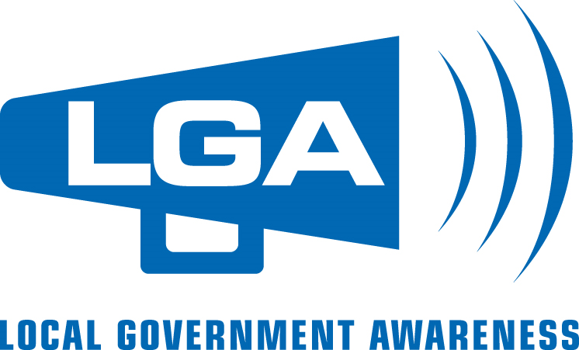

Media Advisory Tips

An advisory is an invitation provided to media to solicit their attendance at an event.

A template for your Local Government Awareness Week media advisory is provided below. Simply fill in the italicized sections and add your logo in the space provided.

When choosing your distribution date, please note that community newspapers often prefer several days in advance of an event.

An advisory is only as good as your follow-up. A phone-call to the assignment editor at the key media outlets in your community can help you ensure that your advisory has been read and gauge the level of interest in your event(s).

In some instances, you may wish to distribute a news release on the day of your event(s) to provide background information and quotes from interested parties. For examples of news release formats, visit the Media Room at www.ubcm.ca or www.news.gov.bc.ca

Media Advisory

Date:
Attention: Assignment Editors

May 19-25, 2019 is Local Government Awareness Week in British Columbia. In honour of this week, (Mayor xx / Chair xx) invites media to attend the following events sponsored by (local government name).

Event Name and brief description
Date
Location

Event Name and brief description
Date
Location

(etc.)

For more information, please contact:

Name/Position:
Contact Information:

